Mirzapur

Goes, UP

Comes down

|  |
| --- |
| FILM REVIEW |

MAYANK SHEKHAR

[Mayank-shek@gmail.com](mailto:Mayank-shek@gmail.com)

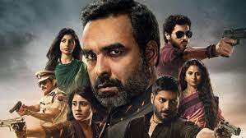

MORE than anyone else, Mirzapur 2 is centerd on Munna tripathi (the undoubtely ‘berod/unique Divyendu sharma). And for whatever it’s worth, you have to give it to the low life munna- while the son of mirzapur’s top-don, he’s not exactly a wastrel, chilling in the comfort of his destiny.

He goes out and works like a henchman on his own, breaking

Bones, building alliance Whatever he’s particularly bright/intelligent is immaterial to the larget idea of legancy/dynasty. That these kid have to work doubly hard to prove themselves in the long run in an expected that’s seldom underst wastrel, chilling in the comfort of his destiny.

He goes out and works like a henchman on his own, breaking bones, building alliance Whatever he’s particularly bright/

|  |
| --- |
| MIRZAPUR 2  ON : Amazon prime video  RUNTIME: 553 minutes  DIR: Puneet krishna  CAST: Divyendu sharma, Pankaj Tripathi, Ali Fazal |

Whatever he’s particularly bright/intelligent is immaterial to the larget idea of legancy/dynasty. That these kid have to work doubly hard to prove themselves in the long run in an expected that’s seldom underst wastrel, chilling in the comfort of his destiny.

He goes out and works like a hard to prove them

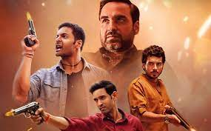

Berod/unique Divyendu sharma). And for whatever it’s worth, you have to give it to the low life munna- while the son of mirzapur’s top-don, he’s not exactly a wastrel, chilling in the comfort of his destiny.

He goes out and works like it.